Creation of DynamoDB table: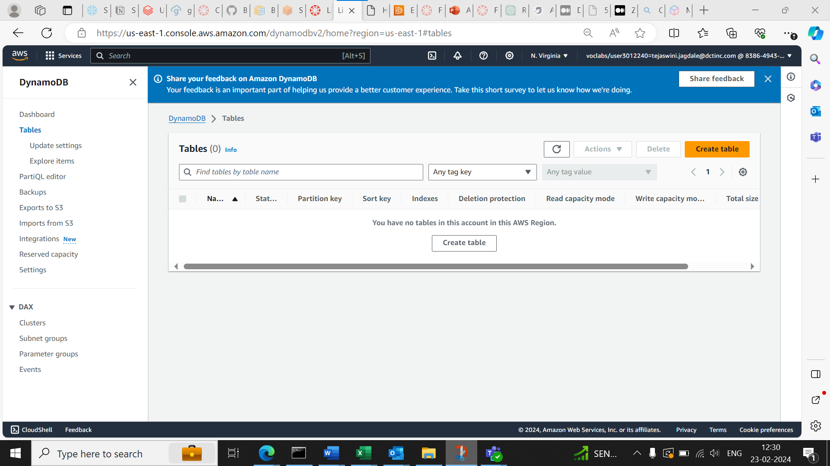

Creating item for table:

Creation of lambda function:

Adding Permissions for DynamoDb access:

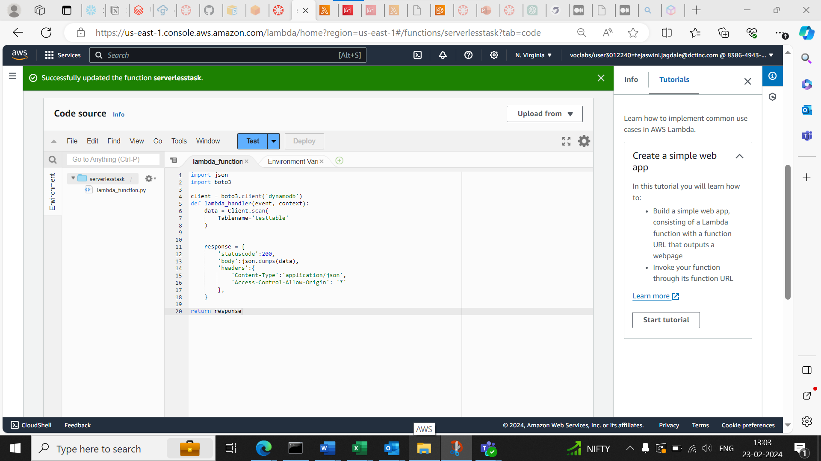

Creation of API :

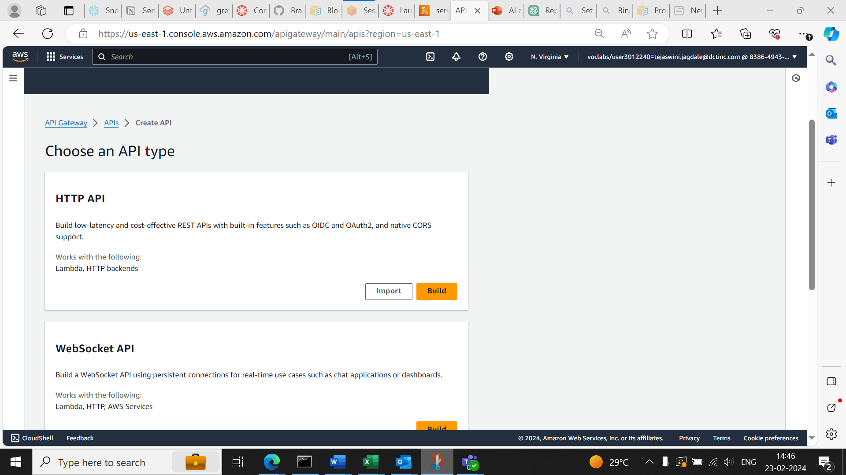

Adding Resources to the API

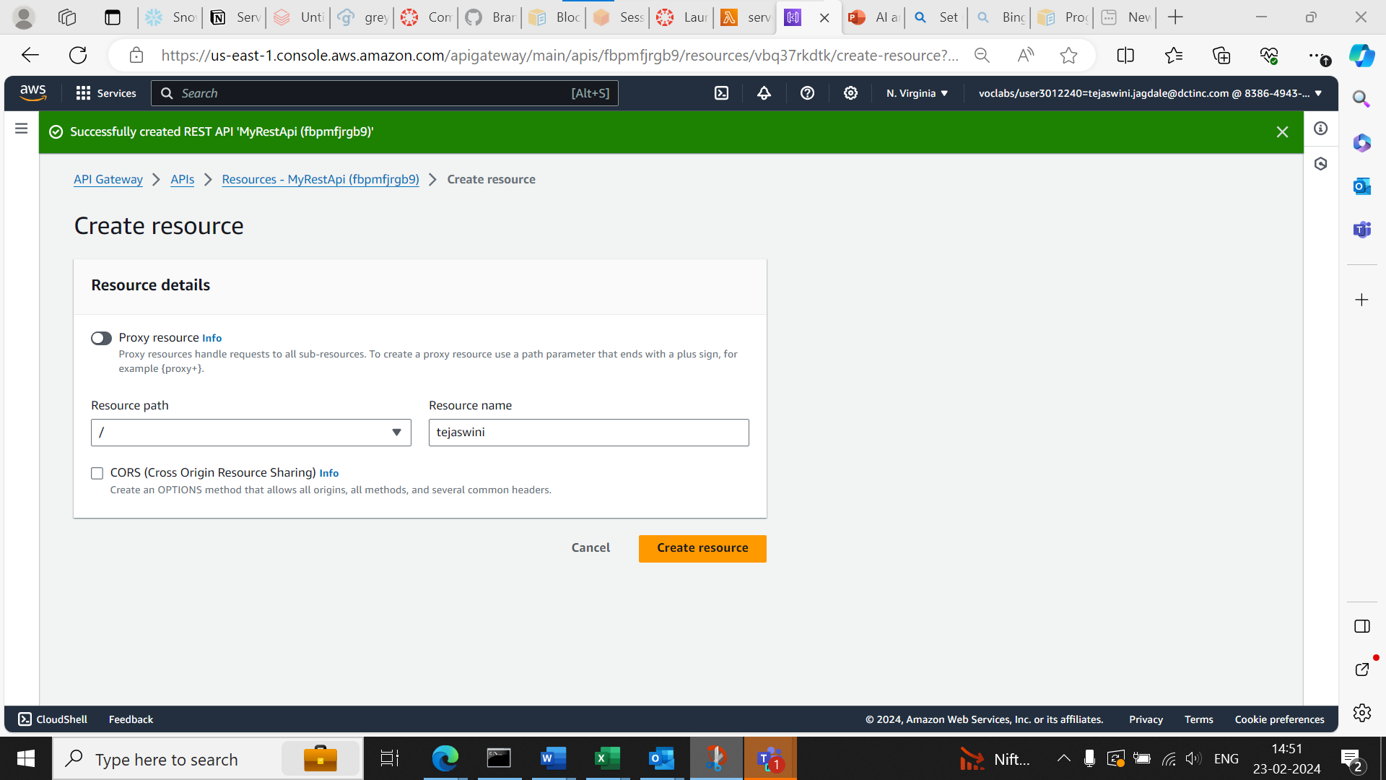

Adding Methods to API:

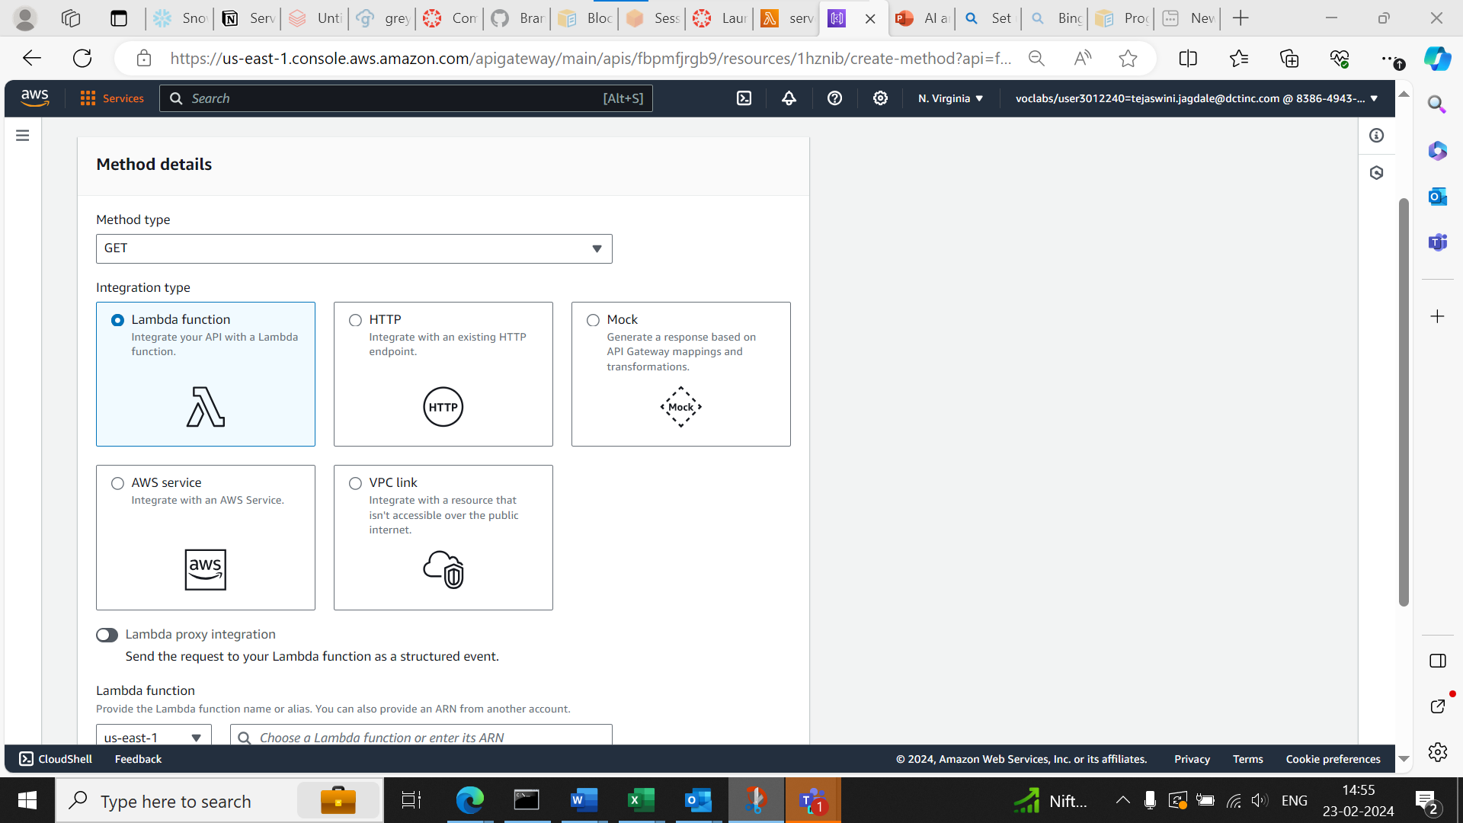

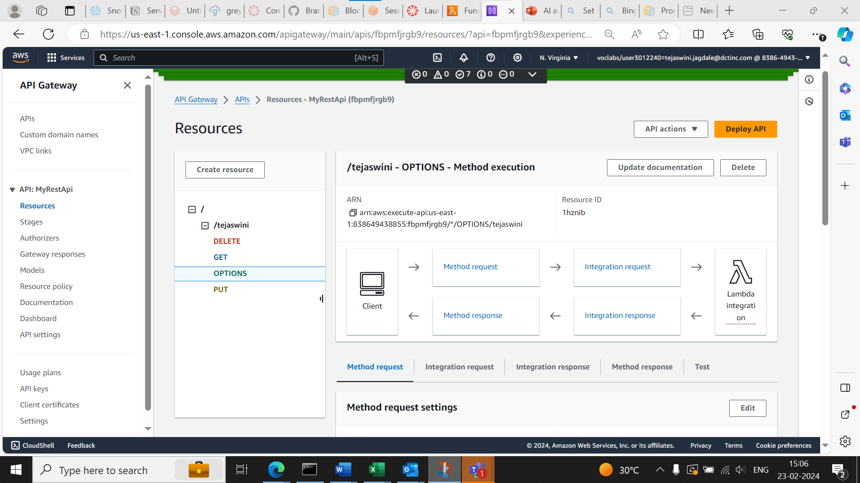

Integration with lambda functions:

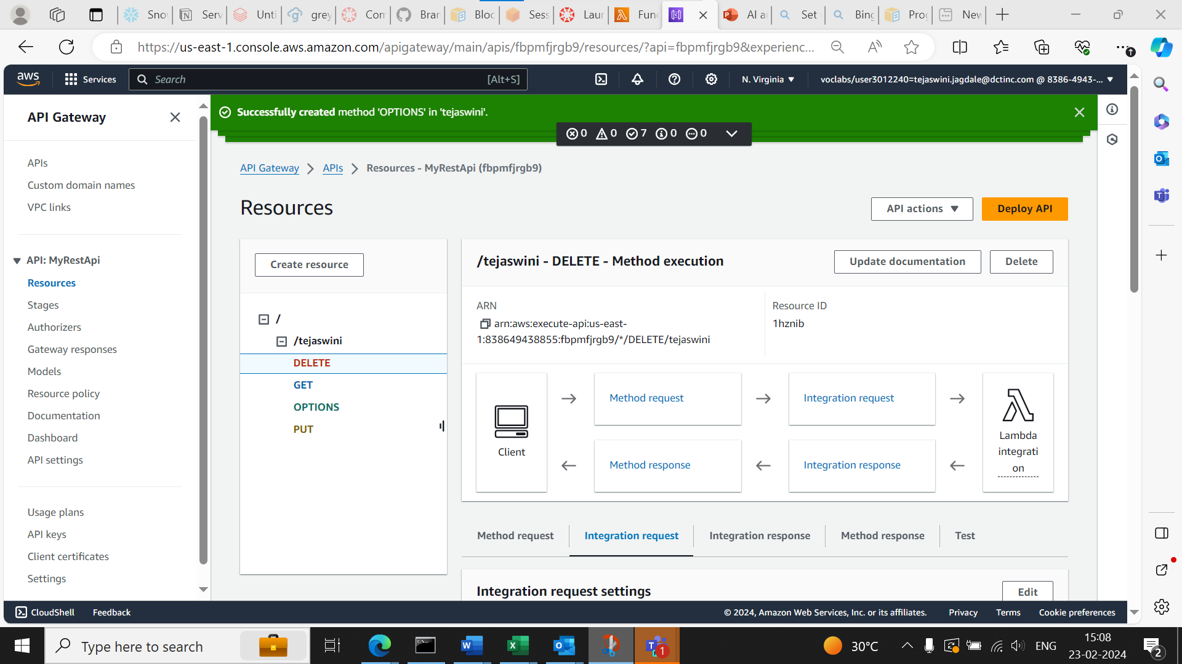

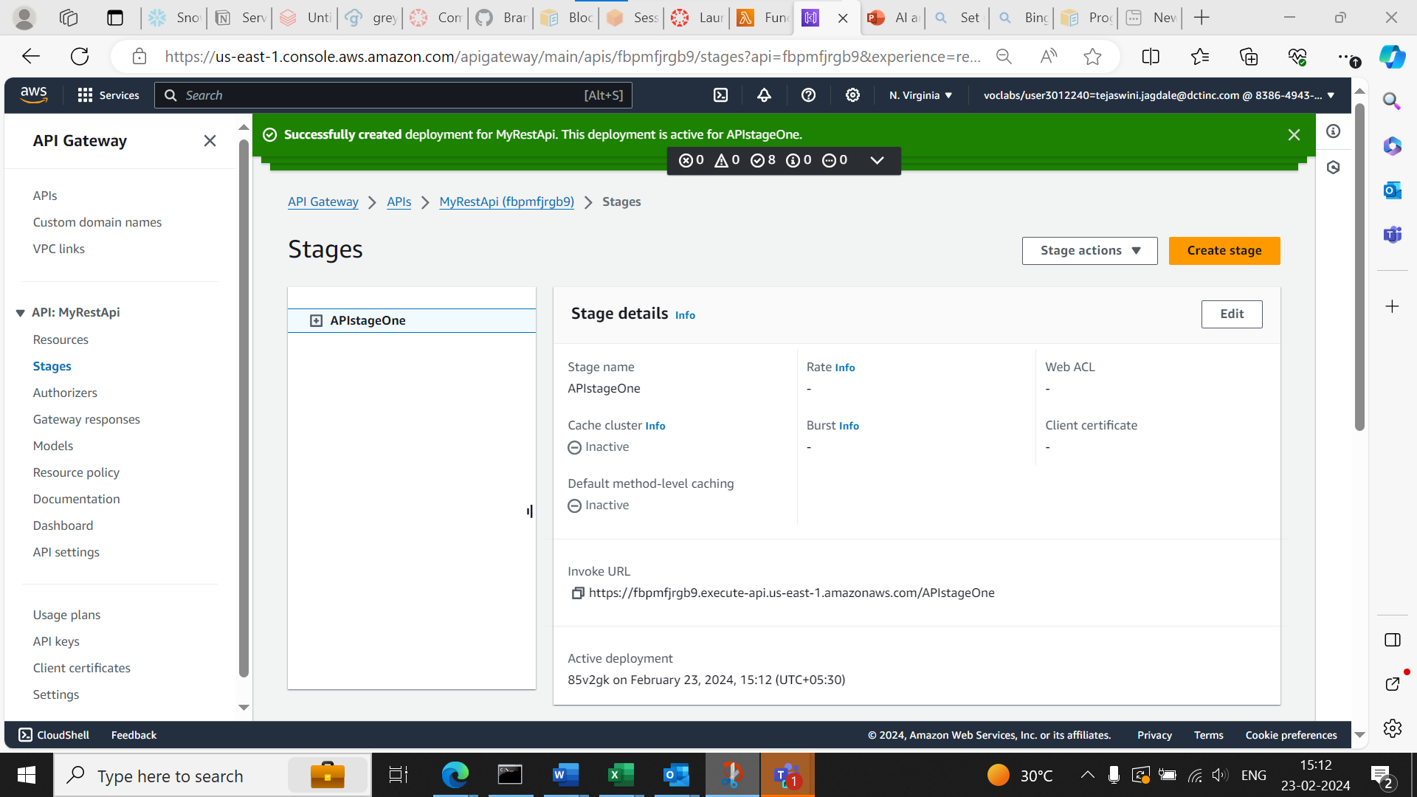

Sent A HTTP request to API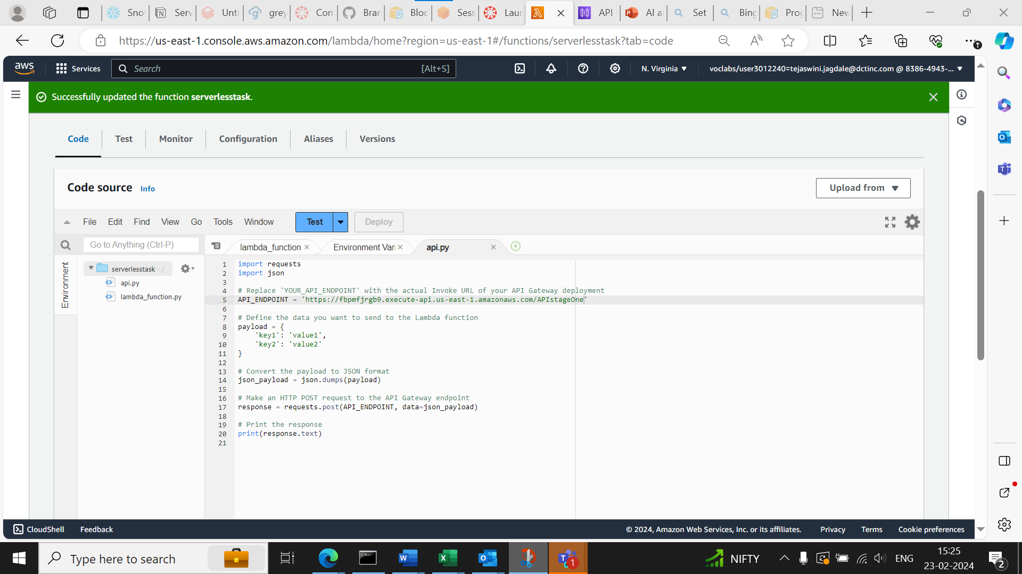

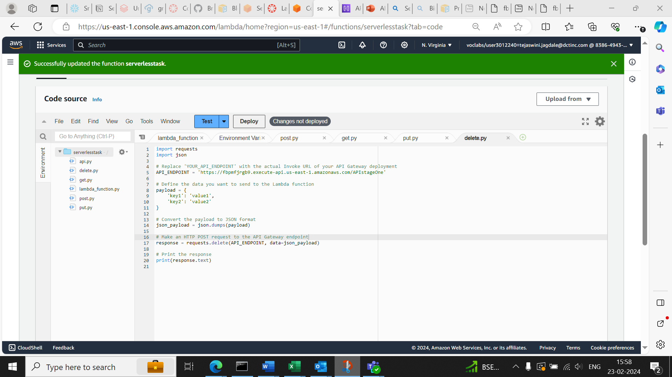

Code to trigger lambda for API: 

Integration:

